**DP  
OP**

|  |  |
| --- | --- |
|  | LoRaWAN Sensor Network for Agriculture |
| LoRaWAN Drone Port Integration  IoT4Ag and IMG University of Florida Gainesville, FL | Preliminary Design Report |

| Date | Team members | Sponsor |
| --- | --- | --- |
| 9/16/2024 | **Daniel Pistorino**, Undergrad  **Oliver Philipp**, Undergrad  **Dieter Steinhauser**, Graduate Design Advisor  **Vernon Crasto**,  Graduate Power Advisor | Dr. David Arnold,  Project Manager |

The LoRaWAN Drone Port Integration team is funded by NSF and sponsored by Dr. David Arnold through the Interdisciplinary Microsystems Group at the University of Florida in Gainesville, FL. The project is dedicated to improving agricultural crop yield by collecting and analyzing real-time data using optimal technologies.

# Table of Contents

Table of Contents 2

Project Summary 3

Abstract 3

Introduction 3

Project Objectives 4

Concept/Technology Selection 4

Project Plan 8

Gantt Chart 9

Business Case 9

Future Works 9

References 10

# Project Summary

# Abstract

IoT4Ag developed a system for organizing and distributing sensor data in agricultural environments. The system’s ground base station collects and organizes data, coordinates autonomous drones, controls wireless power transmission, and monitors battery health. Current communication between the base station and sensor nodes uses a range-limited and power-intensive Wi-Fi protocol. This project replaces the sensor’s Wi-Fi communication network with the low-power LoRaWAN technology and designs the nodes for subterranean deployment.

# Introduction

The agriculture industry needs an efficient solution for collecting, organizing, and distributing sensor data in a natural environment. In [2] sensor data is shown to provide the industry with the ability to recognize, target, and treat yield-effecting conditions. IoT4Ag is developing a system to meet this need.

In 2020, [1] published similar use of LoRaWAN in IoT4Ag for monitoring food storage. Their process differs in both external systems and environmental constraints. Like our design, their nodes transmit sensor data over LoRaWAN. The sensors monitor food storage in a powered environment, whereas our sensors will operate underground using stored power. Their Internet connection uses Wi-Fi, whereas ours uses a Starlink modem. Eliminating the idle Wi-Fi connection allows us to achieve lower power use and operate in fully remote environments. Our ambition is to make a LoRaWAN node to operate with the lowest power consumption we can manage whilst still transmitting our sensor data at the frequency we need it.

# Project Objectives

Design and build a subterranean LoRaWAN-based sensor network and integrate it into the existing drone port.

Figure - Functional diagram showing the integration of the designed components (blue) into the existing drone port design (white).

The existing system includes a drone port station and a wireless charging technology. The drone port station houses and charges a drone that captures aerial image data. The station’s Windows mini-PC connects to the Internet through a Starlink modem and provides remote access to the sensor data software. The existing wireless charger mounts on an agricultural pivot arm and charges the subterranean sensor nodes’ battery as it passes above.

The LoRaWAN sensor network will achieve the following goals:

* Construct a subterranean sensor node with a 5-year lifespan that captures and transmits surrounding soil conditions.
* Construct a LoRaWAN relay to capture node transmissions and broadcast to the gateway.
* Construct a LoRaWAN gateway to forward data to the mini-pc for storage and processing.
* Establish connection and data transfer protocol to the drone port’s mini-pc.
* Analyze power efficiency, SoC tracking, and statistics of LoRaWAN components.

# Concept/Technology Selection

The agricultural industry presents unique design challenges that shape the technology needed to achieve the goal of collecting data needed to improve crop yield. The current system uses a drone to capture and analyze image data to present critical information about crop growth. Analysis of the data from aerial imagery provides critical information needed to improve crop yield. While image data provides beneficial information, soil sampling is still required to discern the optimal crop yield. Analysis of soil properties and environmental conditions further improves crop yield. Soil sampling in this system is achieved through subterranean sensor nodes.

LoRaWAN technology is the optimal choice for this design because it provides very long-range communication with low power consumption. Only a small set of developed technologies can create long-range low-power networks needed for transmitting sensor data. Existing works justify LoRaWAN as an optimal solution. LoRa is compared with Sigfox and NB-IoT in [3]. Here, LoRa is shown as optimal for its ability to adapt to environmental factors, transmit a larger payload, offer increased downlink (from the gateway to the node) connections, and provide encrypted communication. LoRa is independent of external infrastructure which decreases cost, whereas NB-IoT requires an LTE connection in a licensed band. Sigfox is accredited as having better network coverage, but this does not outweigh the benefits offered by LoRaWAN in an agricultural environment.

GPS provides real-time geo-location tracking of both the nodes and the relay. Geolocation data is important because it shows exactly where the samples were taken. Implementing geolocation tracking facilitates ease of installation by eliminating the need to register its location when it is installed. The choice of which GPS module is selected based on the communication protocol it implements and its power efficiency.

STMicroelectronics STM32 microcontrollers offer a low-cost and highly configurable solution to the sensor network design. Not only do these microcontrollers benefit from significant industry support, but they also offer best-in-class power efficiency and implement the needed UART and I2C protocols.

Below are block diagrams that describe the function of the system’s various components.

Figure 2 - LoRaWAN Node hardware design chart.

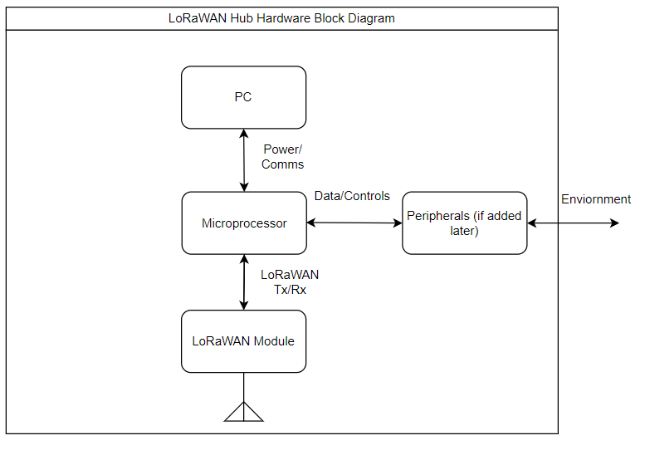

Figure 3 - LoRaWAN Hub hardware design chart.

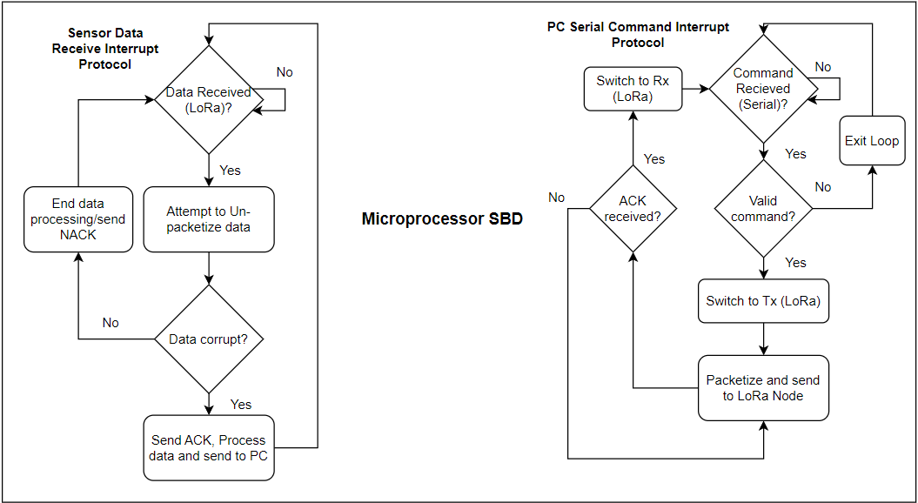

Figure 4 - LoRaWAN Hub software design chart.

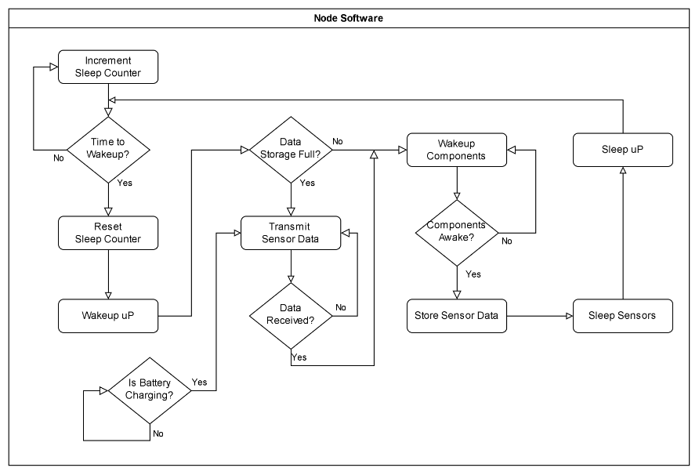

Figure 5 - LoRaWAN Node software design chart.

# Project Plan

The project design team includes Oliver Philipp (OP) and Daniel Pistorino (DP). The team will research, design, implement, and test a system for communicating agriculture sensor data over a LoRaWAN network.

Implementing this system requires researching the existing system functionality, finding the optimal components to implement the system, developing the devices, and testing the implemented designs. Initial research into subterranean communication revealed soil moisture significantly impedes communication between node and gateway. Consequently, the system design was extended to include an optional relay. Implementation of the optional relay is postponed, pending a study of the LoRaWAN gateway and node communication effectiveness.

The dual component nature of the design leads to a natural distribution of work. The hub, which involves creating a LoRaWAN gateway and communication with the Windows mini-pc, is assigned to OP as a project task. OP was selected for this task because of his experience with computer network communications and software development. The node, which captures soil sensor data from a subterranean enclosure, is assigned to DP as a project task. DP was selected for this task because of his experience with hardware design and knowledge of power systems.

The design of both components follows the same timeline, that is depicted by a Gantt chart in Figure 6. Initially, the Node and Hub hardware designs are completed while awaiting the delivery of microcontrollers. The controllers are then built and tested on breadboards. Once the final breadboard design is functional, the printed circuit boards will be ordered. The programming of the LoRaWAN network and sensor data encodings will occur while the PCBs are manufactured. When the programming is complete, the boards are assembled and distributed for field testing. The acquired data will then be processed and analyzed for the final report.

# Gantt Chart

Figure 6 - LoRaWAN Drone Port Integration project 17-week timeline depicted on a Gantt chart.

# Business Case

A business case for our product would be a farmer who wants to optimize the irrigation of their land by knowing when it is best to run their irrigation pivot system over their crops. Our design specifically measures the soil’s properties like moisture and will be readily available to farmers from their computers through the LoRaWAN network. Knowing when the soil gets too dry or too moist can be the difference between an average annual yield and an exceptional annual yield.

# Future Works

Extending our LoRaWAN Integration is achieved by increasing the number of soil properties measured, and incorporating additional environmental sensors to measure the atmosphere or crops themselves. If range or signal strength proves insufficient then the relay will need to be implemented. The relay will also make possible the ability to extend the system beyond the range of a single transmitter broadcast.

More combinations of different low/high power and long/short range communication protocols can be adopted to optimize certain aspects of the relay networks for specific applications that warrant stronger/faster data transmission through the soil or to meet lower power specifications.

The concept of the LoRaWAN network can also be extended past the IoT4Ag space and can be used in retail security, industrial safety, emergency communications in hospitals, and any other application that would benefit from low-power and long-range communications.

# References

|  |  |
| --- | --- |
| [1] | B. C. C. S. K. E. G. S. Esma Kokten, "Low-Powered Agriculture IoT Systems with LoRa," *IEEE Microwave Theory and Techniques in Wireless Communications,* 2020. |
| [2] | P. Rajak and e. al., "Internet of Things and smart sensors in agriculture: Scopes and challenges," *Journal of Agriculture and Food Research,* vol. 14, p. 100776, December 2023. |
| [3] | Wu, S., Austin, A.C.M., Ivoghlian, A. *et al.* “Long range wide area network for agricultural wireless underground sensor networks.” *J Ambient Intell Human Comput* **14**, 4903–4919 (2023). https://doi.org/10.1007/s12652-020-02137-1 |